POLYNIOMIAL INTERPOLATION

% Define the measured data points

x_data = [0.0,1.0,2.0,3.0,4.0,5.0];

y_data = [44.5,43,42,40.4,39.5,37.6];

% Polynomial interpolation

p1 = polyfit(x_data,y_data,length(x_data)-1);

x_interp = linspace(0,5,100);

y_interp = polyval(p1,x_interp);

% Plot the results of interpolation

figure

plot(x_data,y_data,'o',x_interp,y_interp);

title('Polynomial Interpolation');

xlabel('x');

ylabel('Temperature');

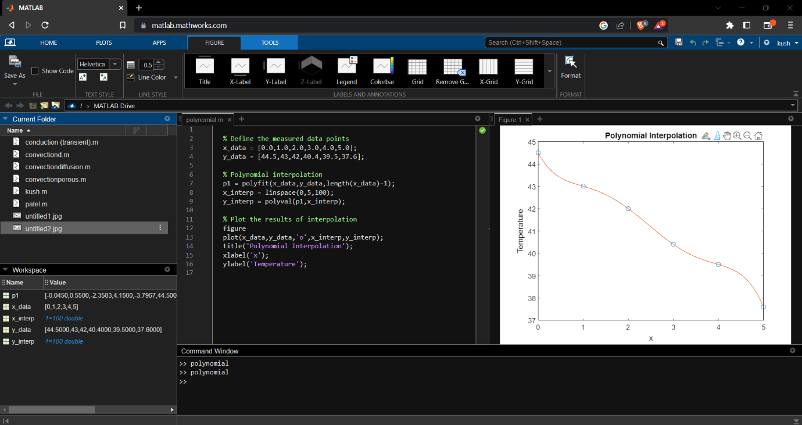

POLYNOMIAL APPROXIMATION